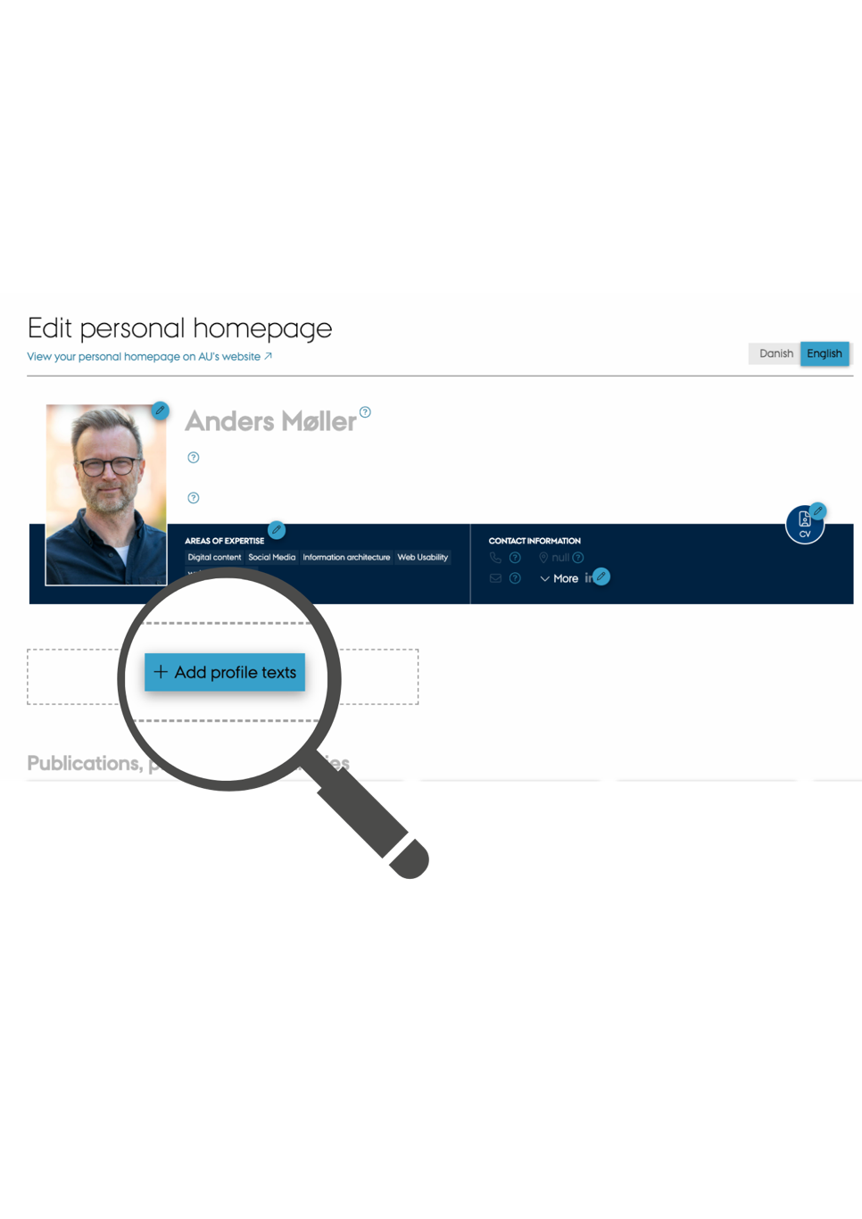

Do you need help getting started?

If you are having trouble getting started writing, try filling in the [BLANK SPACES] in these texts.

Each text should be a maximum of 500 characters including spaces.


Profile

As a [FUNCTION], I work/conduct research/am interested with/on/in [SUBJECT AREA]. In my work, I am responsible for/am particularly interested in/primarily deal with [PRIMARY TASKS]. I have a degree/background in [SUBJECT AREA/PROFESSIONAL FIELD] and have experience with [ ]/ my current roles include [ ].

Work areas

My primary area of ​​responsibility is [OVERALL WORK AREA] including [SUB-AREAS]. I also contribute to/I also work with [OTHER WORK AREAS/WORK TASKS].

Research

I am conducting research on [OVERALL RESEARCH AREA] with particular focus on [SPECIALIST AREA]. Using [RESEARCH METHOD], my goal is to [RESULT]. My research contributes to [TARGET GROUP] being able to [EFFECT FOR TARGET GROUP].

Degree programmes

I teach [SUBJECT FIELDS/COURSES] on [DEGREE PROGRAMME]. Using [TEACHING METHOD], my goal is for [TARGET GROUP] to [TEACHING BENEFITS]. I have also contributed to the development of [TEACHING MATERIALS/TEXTBOOKS/ACADEMIC REGULATIONS].

Collaborations

I collaborate with [COLLABORATION PARTNERS] on [SUBJECT AREA/INITIATIVES/PROJECTS]. The goal is to [PURPOSE OF COLLABORATION].

Consultancy

Based on my research in [RESEARCH AREA], I advise [TARGET GROUP/BODY/COUNCIL] on [PURPOSE OF ADVICE]. I am also a member of [BOARDS, COUNCILS, PANELS AND STEERING COMMITTEES].

______

Let AI help you

Once you have filled in the blanks in the relevant texts, you can try inserting them individually into e.g. ChatGPT or Co-Pilot to create some linguistic variation.

1. Insert this text into e.g. Co-pilot or ChatGPT:

“Rewrite this text so a recipient without special academic prerequisites will be able to understand it. Shorten it to 500 characters including spaces.”

2. Then insert your text.

3. Evaluate the output and then rewrite your text

